**Assignment 1**

**Name: Aliyan Ahmed Cheema**

**Reg # FA22-BCE-028**

**Pseudo Code:**

**Algorithm**: Simple Linear Regression

**Input**: Dataset with two features (X: Years of Experience, Y: Salary)

**Output:** Linear Regression model with coefficients (slope and intercept)

1. Compute the means of X and Y:

mean_X = average(X)

mean_Y = average(Y)

2. Compute the slope (b1) using the formula:

numerator = Σ (Xi - mean_X) * (Yi - mean_Y)

denominator = Σ (Xi - mean_X)²

b1 = numerator / denominator

3. Compute the intercept (b0):

b0 = mean_Y - (b1 * mean_X)

4. Return the linear equation: Y = b0 + b1 * X

5. Predict values using the obtained equation.

6. Compute performance metrics:

- RMSE: sqrt(mean((Y_actual - Y_predicted)²))

- MAE: mean(abs(Y_actual - Y_predicted))

- R2 Score: 1 - (Σ(Y_actual - Y_predicted)² / Σ(Y_actual - mean_Y)²)

7. Plot the dataset and regression line.

**My Implemented Model:**

**Built in Model (sklearn):**

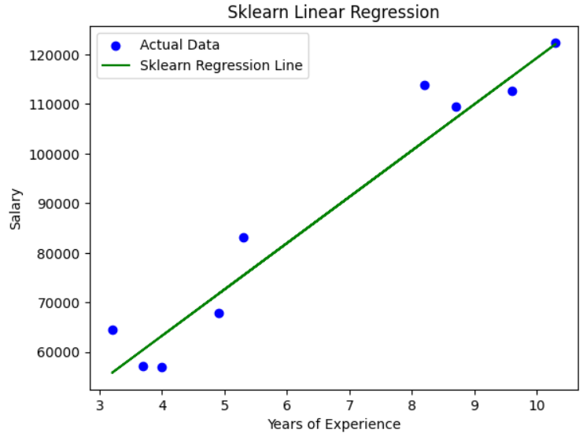

**Table:**

|  |  |  |
| --- | --- | --- |
| **Model** | **Intercept(b0)** | **Slope(b1)** |
| **Manual Regression** | 25918.438335 | 9339.081724 |
| **Sklearn Regression** | 25918.438335 | 9339.081724 |